# Initial Discussion of Software Architecture and Technology Rationale

# Technologies Used

The technologies that are required for this project are as follows; Java for the main implementation, Database Technologies such as MySQL for storing user data, OpenStreetMap which generates the mapping system for the properties, HTML for the structure of the front end web pages, CSS for the style of the web pages, JavaScript for taking actions on web pages and JSP for dynamic web pages.

We will be using the Spring MVC framework which uses a model, view and controller framework to map the web pages, we can also make use of Spring security for password encryption.

This is a graphical representation of the Spring MVC framework, the 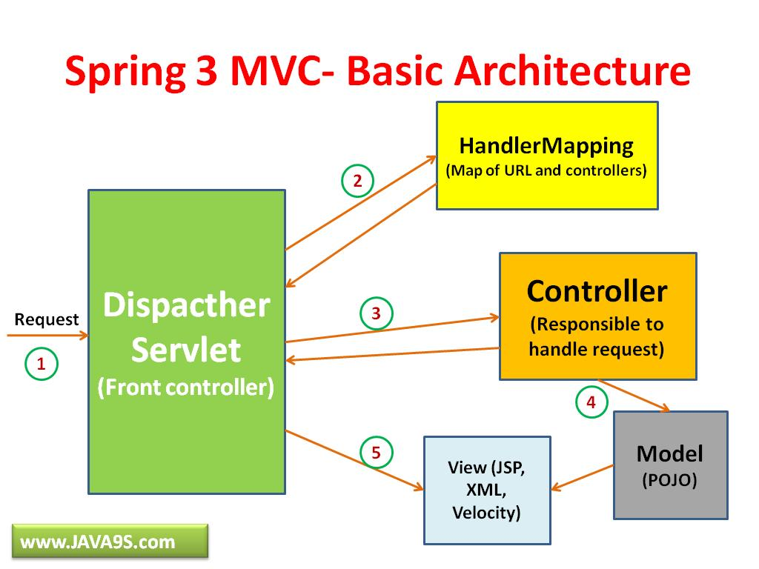**front controller** receives a request. It is then passed to the **HandlerMapping** which then is passed back to the front controller which is passed to the **Controller** which is responsible for processing user requests and building appropriate model and passes it to the view for rendering. It will then be directed to the request to the **Model** which encapsulates the application data and in general they will consist of POJO(Plain old Java object). It is then passed to the **View** which is is responsible for rendering the model data and in general it generates HTML output that the client's browser can interpret.

# Initial Prototype

The initial prototype should include most if not all of the key features of the web application, it would need the registration for the Searchers and Landlords and login system for the Searchers and Landlords and Administrators , where a student or a professional can register to become a Searcher, a Searcher can search for properties in Leicester. Which is represented graphically on a map, they can express interest in a property which alerts the Landlord of the property. A searcher should be able to also sign up for the buddy system, if they do sign up to this service they will see other people on the property that they could potentially buddy up with. Searchers should be able to message their potential buddy and the landlord of the property. The prototype should also allow Landlords to register and login. A Landlord can create/manage/delete a property they own, they can also message potential tenants(searchers) and book meetings. Both these users should be able to report a user. The Administrators should be able to login and review reports from users and take action upon reviewing.